Administration
Workshop

Document Type | Administration
Current Version | 2.0
Date Last Updated | Apr. 16, 07
Authors | Manoj Lal, Abhishek Jadhav, Parag Koshti ,Manish Korgaonkar
Date Created | April 9,2007
Approved By | Manish Pimple
Approved Date | Apr. 11, 07

Table of Contents
1. Table Creation 6
1.1 Creation of Table: 6
1.2. Creation of table with Indexes Defined in table: 6
1.3. Insertion of Data in the Table with different scenarios: 6
1.4. Deletion of Data: 7
1.5. Dropping of Table: 7
1.6. Updates made to the table: 8
1.7. Change from No Fallback to Fallback table: 8
1.8. Adding ,Renaming, Dropping columns: 8
1.9. Creating a Multiset Table: 9
1.10. Insertion of data into the SET table: 9
1.11. Creating Global Temporary Table : 9
1.12 Altering the definition of a Global temporary table: 10
1.13.Creating Volatile Table: 10
1.13. Creating a Partitioned Primary Index (PPI)Table: 11
Key Points to note: 11
2. Table Level and Column level Constraints 13
2.1. Column Level Constraints: 13
2.2. Defining the Table Level constraints: 13
2.3. Inserting the data in the table satisfying all the constraints: 13
2.4. Example of Named Column level constraints: 14
2.5. Adding Constraints after Table Creation: 14
2.6 Dropping of unnamed constraint : 15
Key Points to note: 15
3. Create Index 16
3.1. Creation of Indexes: 16
3. 2.Creation of USI: 16
3.3. Creation of NUSI: 16
3.4. Failure of creating/dropping a Primary Index: 17
3.5. Dropping Indexes: 17
Key Points to note: 18
4. Collecting Statistics 19
4.1. Collecting Statistics : 19
4.2 Collecting Stats on a column Using Sample of data and firing an Explain on it: 19
4.3. Drop Stats Statement: 19
4.4. Collecting Stats For a PPI Table: 20
4.5. Dropping Stats on Columns of a PPI Table and Executing HELP Stats Statement: 20
4.6. Collecting Stats on a Global Temporary Table: 21
4.7. Creating Volatile Table and Collecting Stats on it: 21
Key Points to note: 21
5. Views 23
5.1. Creating a View and selecting the Columns from the view: 23
5.2. Creation of Views using Appropriate Privileges: 23
5.3. Updates to the View: 24
5.4. Failure of not being able to view a column due to its absence in the View: 24
5.5. Creating a Join View: 24
5.6. Renaming the columns of the view: 25
5.7. Replacing an existing view: 25
5.8. Creating an aggregated View: 26
5.9. Performing Nested Aggregation: 26
5.10. View with Check option: 27
5.11. Failure of Creating a index on a View and Failure of using an Order By Clause in a View: 27
Key Points to Note: 28
6. Macro 29
6.1. Creation of Macro: 29
6.2. Replacing a Macro: 29
6.3. Creating a Parameterized Macro: 30
6.4. Parameterized Macro to insert data: 30
6.5. Executing the Insert Macro: 30
6.6. Upserts against UPI tables: 31
6.7. Upserts against NUPI tables: 31
Key Points to Note: 32
7. Creating, Modifying and Dropping users 33
7.1 Creating a user : 33
7.2 Modify User : 33
7.3 Drop User: 33
7.4 Create Profile : 34
Key Points to Note: 34
8. Grant and Revoke 35
8.1 Grant Statement: 35
8.2 Revoke Statement: 36
9. Create Roles 38
9.1 - Create Role: 38
9.1.1- create role, assign rights to it and grant role to a user 38
9.1.2- grant role with admin option 38
10. Triggers 40
10.1- Creating a Row level Trigger (before insert): 40
10.2- Creating a Row level Trigger (after insert) 40
10.3- Creating a Row level Trigger (before update) 40
10.4- Creating a Row level Trigger (after update) 41
10.5- Creating a Statement level Trigger : 41
10.6- Cascading of triggers: 41
10.7- Ordering of triggers: 41
10.8- Backward References of triggers: 42
10.9- Changing the creation timestamp: 42
Key points to Note- : 42
11. Stored Procedures 44
11.1- Parameterized stored procedure : 44
11.2- Parameterized procedure using IF-ELSEIF-ELSE statement: 45
11.3- Looping procedure: 45
11.4- WHILE-DO loop procedure: 46
11.5- Retrieving a row from a table: 46
11.6- Retrieving more than one row from a table (erroneous procedure): 47
11.7- To drop constraints 48
Key Points to note: 49

Table Creation

1.1 Creation of Table:
The table is created using the Create table statement and the create table statement creates and stores the table structure definition in the Teradata Data Dictionary. The default for table creation is no fallback and no journal. Fallback maintains one more copy of the same table.

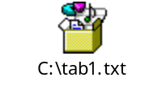

1.2. Creation of table with Indexes Defined in table:
The table emp_data1 is created with indexes defined in it. The table emp_data1 is created using the create table statement. Here a UPI is created on employee_number and a NUSI is created on department_number. The help database statement shows the table created. T and V displayed in the help statement stands for table and view respectively.

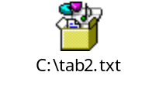

1.3. Insertion of Data in the Table with different scenarios:
The data is inserted into the emp_data table through the insert statement. The first insert statement succeeds as it satisfies all the conditions. The 2nd insert statement fails as there are few values for the assignment list. The 3rd insert statement fails as a duplicate value for employee_number is inserted in it because a UPI is created on employee_number.

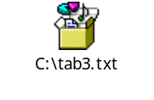

1.4. Deletion of Data:
The delete statement shown below removes all the data from the table. After the data is deleted from it, the select statement below shows that there is no data in the table.

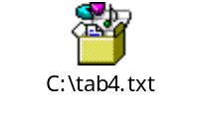

1.5. Dropping of Table:
The drop table removes the definition of the table from the Data Dictionary as seen below. After the table is dropped, the help statement shows that the table emp_data no longer exists in it.

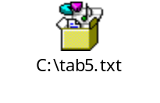

1.6. Updates made to the table:
Updates can be done to the table after the creation of the table using Alter table statement. Columns can be added to the table here as shown below the 2 columns educ_level and insure_type are added to the table after the table is created using the Create table statement. The show table statement displays the definition of the table so created.

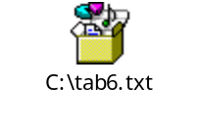

1.7. Change from No Fallback to Fallback table:
The NO FALLBACK statement in the Create table statement can be changed to FALLBACK table and vice versa. using the Alter table statement as shown below. The show table shows that the table emp_data is now a Fallback table.

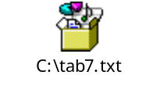

1.8. Adding ,Renaming, Dropping columns:
The 2 columns educ_level and insure_type added to the table after the table creation can be dropped from the table using the Alter Table statement as shown below. Also the column in the table can be renamed using the rename option. The column birthdate is renamed from birthdate to birth_date using the Alter table statement.
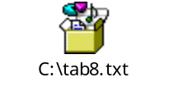

1.9. Creating a Multiset Table:
The table is created using the create table statement. The table table_1 is a Multiset table which allows duplicate rows and a Fallback table which protects from AMP failure. The various table level attributes declared below are Datablocksize, Frees pace and Checksum. Also if no primary index is defined for a table, the primary index defaults to the 1st column(budget_amount shown below) defined in the table. The 1st and 2nd insert statement succeeds inspite of being a duplicate copy of each other is allowed, as the table is a Multiset table which allows duplicate rows.

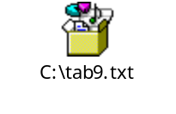

1.10. Insertion of data into the SET table:
The table created using the Create table statement is a SET table which does not allow duplicate rows. As shown below, the table table_2 is a SET table and a Fallback table. The 1st statement succeeds as is satisfies all the conditions and the 2nd statement fails because it is a duplicate copy of the 1st row and the table declared is a SET table which does not allows duplicate rows.

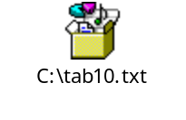

1.11. Creating Global Temporary Table :
The Global Temporary Table gtt1 has been created using the create statement as shown above. The show table gtt1 shows the definition of the global temporary table. The global temporary table is local to a session and occupies temp space.
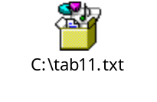

1.12 Altering the definition of a Global temporary table:
This can be done only if there are no materialized instance

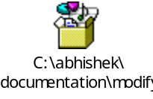
Note: On commit delete rows / On commit preserve rows
You cannot change the ON COMMIT Properties of a global temporary table if any materialized instance of the table exists anywhere in the Teradata Database.

1.13.Creating Volatile Table:
The volatile table is created using the create statement. Also the volatile tables cannot be seen in the database user01 as seen in the help statement. The volatile table is local to a session and occupies spool space.

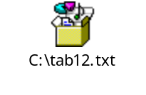

ALTER TABLE Not Valid for Volatile Tables
You cannot use ALTER TABLE to change the definition for a volatile table. Instead, you must DROP the old table and CREATE a new one to replace it.

1.13. Creating a Partitioned Primary Index (PPI)Table:
The Partitioned Primary index (PPI) table is first created using the Create table statement and the partitioning column is o_custid. The NUPI and USI is created on o_orderid. If the partitioning column is not a part of the primary index, the primary index cannot be unique.

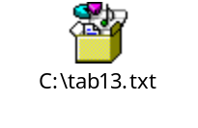

Key Points to note:
- The Create table statements have 4 major elements: Create SET/MULTISET table, Create table options, Column definitions, Index Definitions
- Column definitions: define each column in the table
- Index definitions: Specify Indexes for physical access to data
- Table Protection options: Fallback or No Fallback protection
Before Journal, After Journal, With Journal table.
- Duplicate row options:
SET-no duplicate rows allowed
MULTISET-duplicate rows allowed
- To remove a table definition from the Data Dictionary the DROP command must be executed.
- To remove all data from a table the DELETE command must be executed.
- The ALTER table can be used to add, drop, rename columns from an empty or populated table.

2. Table Level and Column level Constraints

2.1. Column Level Constraints:
The table is created using the Create table statement with constraints defined in it. All the constraints are at column level. Here the various column level constraints are primary key placed on emp_id, the unique constraint on id_badge_number, the check constraint on salary and the references constraint on job_code. Column level constraints are defined only on 1 column at a time.

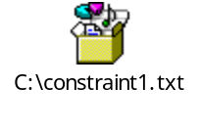

2.2. Defining the Table Level constraints:
Here all the constraints in the employee_badge1 table are at table level. The Table level constraints are useful for multi-column constraints. May be named or unnamed. The table level constraint defined in this table is check constraint which is placed on salary and job_code.

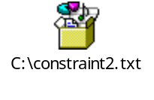

2.3. Inserting the data in the table satisfying all the constraints:
The table collevel _constraint includes the 4 constraints as col1 which is the Primary key constraint which does not allow nulls and duplicates,col2 which is the Unique constraint does not allow nulls and duplicates,col3 which is the Check constraint which verify values or range and the References constraint which relates to other columns. The 1st insert succeeds as it satisfies all the conditions ,2nd insert statement fails due to uniqueness constraint violation,3rd insert succeeds due to condition satisfaction,4th insert fails due to primary key constraint violation and 5th insert statement fails due to Referential constraint violation.

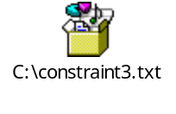

2.4. Example of Named Column level constraints:
The table dept_constraint is created using the Create table statement and it includes 2 column level constraints (Foreign Key and check) named as refer_1 and dn_check_name.

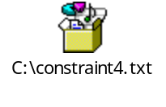

2.5. Adding Constraints after Table Creation:
The table is created and then the constraints are added to it after the table creation.

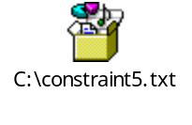

2.6 Dropping of unnamed constraint :

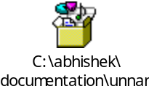

Key Points to note:
- The various column level constraints are Primary Key, Unique, Check, References. Constraints may be named or unnamed.
- Column level constraints are defined only on 1 column at a time.
- Primary key: May be defined on NOT NULL columns. Guarantees uniqueness
- Unique: May be defined on NOT NULL columns. Guarantees uniqueness.
- Check: Allows Range or value constraints be placed on the column
- References: Requires values to be referenced checked before being
allowed.
- The Table Level Constraints are an alternate way to set column constraints.
- Useful for Multi-column constraints.

The Table level constraints may be named or unnamed.

Data Dictionary Views:

- DBC.tableconstraints : This view contains a row for each table-level
Constraint defined in the system
- DBC.showcolchecks : This view provides information about column
Constraints.
- DBC.Columns : This view provides information about columns of any
table or view

3. Create Index

3.1. Creation of Indexes:
The Index can be created at the time of table creation or can be created explicitly using the Create Index statement. One difference is that Create Index statement cannot create a Primary Index, only Secondary Indexes on an existing table. In the below statement, a UPI is created on the employee_number column and a NUSI on the department_number column of the employee table.
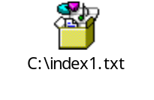

3. 2.Creation of USI:
After the table is created using the Create table statement with a NUPI on employee_number, a USI named as full name is created on last_name, first_name columns of the emp_data table. Later on the index so created can be seen with the help of show table statement.

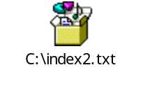

3.3. Creation of NUSI:
The table created using the Create table statement includes NUPI on employee_number column, USI on first_name, last_name column and a NUSI is created on job_code column of the emp_data using the Create Index statement. The changes made to the table can be viewed using the Show table command.

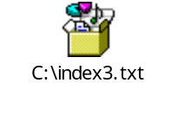

3.4. Failure of creating/dropping a Primary Index:
The help index statement shows all the indexes defined on the table and includes the columns on which the indexes were build. The primary index cannot be build using the Create Index statement which can be seen below with the failure 3525.Only the Secondary indexes can be created with Create Index statement.

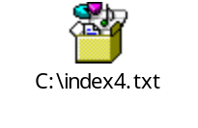

3.5. Dropping Indexes:
The indexes after they are created on the table can latter be dropped using the Drop Index statement .The indexes declared on the table below (full_name, job_code) are dropped with the help of Drop Index command. The help index statement shown below shows that there is only one index (employee_number) defined on the table.

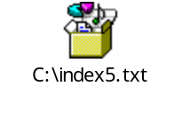

Key Points to note:
- Secondary Indexes may be created on existing tables. May be defined as Unique (USI) or Non-Unique (NUSI) .May include upto 64 columns. May be named or left unnamed.
- Create index cannot create a Primary Index, only secondary indexes on an existing table.
- Help index shows the information on all indexes defined for a table.
- Drop Index is used to drop a secondary index from a table. Only one index may be dropped per drop index command. Drop index physically removes the sub-table comprising the index.
- Indexes may be dropped by referencing the index name or by referring its column definition.
- If no indexes are defined for a table, the indexes default to the 1st unique column. If no unique column is present it takes the first column defined for the table.

4. Collecting Statistics

4.1. Collecting Statistics :
If a particular object does not exist then statistics cannot be collected on that object as the object no longer exists. Statistics can be collected on normal tables using collect statistics statement as shown above. Collected statistics are not automatically updated by the system. The user is responsible for refreshing collected statistics.
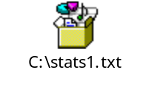

4.2 Collecting Stats on a column Using Sample of data and firing an Explain on it:
Here the statistics is collected using sample of the data. Also the Explain statement shows in the step no 2 as “Sampling Enabled”. The Dynamic amp samples statistics are stored in the Data Dictionary Cache.

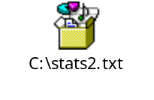

4.3. Drop Stats Statement:
The collected statistics can be dropped using the Drop Statistics statement. After the statistics are dropped for the required columns, the help statistics statement displays the info for the remaining columns.
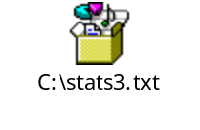

4.4. Collecting Stats For a PPI Table:
The Partitioned Primary index (PPI) table is first created using the Create table statement and the partitioning column is o_custid. The statistics are collected on o_orderid and o_custid. The help statistics statement displays the info about these columns. Statistics on the partition column provide info about partitions and allow the optimizer to generate a more aggressive plan with respect to PPI tables.

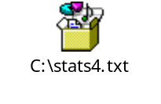

4.5. Dropping Stats on Columns of a PPI Table and Executing HELP Stats Statement:
After the statistics are dropped on the columns of the PPI table using the drop stats statement , the help stats statement shows that there are no stats defined for the table.

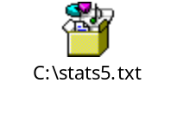

4.6. Collecting Stats on a Global Temporary Table:
When a help statement is fired for a particular database, the global temporary table can be seen in that help database statement. The definition of the global temporary table is known to the data dictionary. Statistics can be collected on global temporary table and stats can be viewed using the help stats statement. The date and time field show when the statistics were last collected or refreshed.

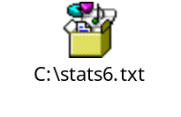

4.7. Creating Volatile Table and Collecting Stats on it:
The volatile table is created using the create statement Statistics cannot be collected on volatile tables. Also the volatile tables cannot be seen in the database user01 as seen in the help statement. The volatile table is local to a session and occupies spool space.

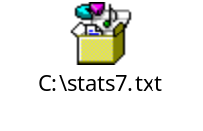

Key Points to note:
- Without collected statistics, the Parser relies solely on dynamic samples.
- Collected statistics are not automatically updated by the system.
- The user is responsible for refreshing collected statistics.
- The Optimizer is more aggressive when it has collected statistics. It is more conservative when it must rely on dynamic sampling.
- Refresh the statistics when 5%-10% of the table’s rows have changed.
- For best results, collect statistics on:
- All non-unique indexes
- The UPI of tables with less than 1000 rows per Amp.
- Any non-indexed column used for set selection or join constraints

5. Views

5.1. Creating a View and selecting the Columns from the view:
Here a View named as emp_view is created using the Create View statement. The view is created on the Employee table which is the Base table. The columns are restricted from the base table by explicitly listing the desired column names from the base table. The column names which are restricted here are employee_number, last_name, salary_amount and the rows from the base table are restricted by using the Where clause (shown above).The view can be seen in the database using the help database statement .

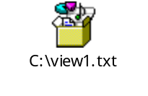

5.2. Creation of Views using Appropriate Privileges:
For creating a View, the user must have appropriate privileges on the database for creation of the view. Here the database user_01 is selected and the select statement displays the data from emp_view. Whatever columns are selected from the base table, the data of those columns is displayed as shown.

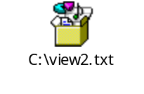

5.3. Updates to the View:
The view can be updated using the Update statement .Here the salary_amount of Hopkins is changed from 37900.00 to 50000.00 and the change is seen in the select statement. The view cannot be used for update operations if it contains the following:-
- data from more than 1 table
- The same column specified twice
- Derived columns
- A Distinct clause
- A Group By clause

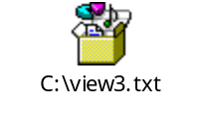

5.4. Failure of not being able to view a column due to its absence in the View:
Here the column birthdate added in the table employee cannot be seen in the view as seen in the below Failure statement because the column birthdate has not been selected in the view.

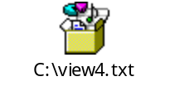

5.5. Creating a Join View:
Here a Join view emp_dept is created on the tables Employee and Department with a inner join on column department_number. A Join View consists of columns from more than 1 table.

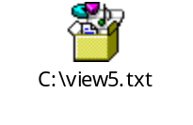

5.6. Renaming the columns of the view:
A View cannot be created with the same name if the view of that name already exists. Views can be renamed as shown below. After renaming the columns of the view, the new renamed columns in the view can be seen using the select statement as shown below.

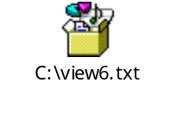

5.7. Replacing an existing view:
The view once created can be seen with the help database statement. An existing view can be replaced with a new view by using the Replace view statement as shown below. The old view emp_view is being replaced with the new view emp_view2 (as shown below).

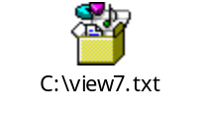

5.8. Creating an aggregated View:
An aggregated view can be created by using the Create view as shown below. An aggregated view named as deptsal has been created as shown below. Aggregate views are views which contain aggregate expressions or derived columns. It is always necessary to assign a name to these columns so that they may be referenced within the view. Aggregations can be performed directly on the table employee as shown in the 1st select statement or it can be performed by using the aggregated view by performing all the aggregations in the view itself and assigning names to those columns.

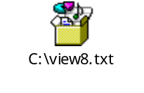

5.9. Performing Nested Aggregation:
An view with aggregates may itself have aggregate operations performed against it. This is referred to as ‘Nested aggregation’ .In the following example, aggregation operations are performed against rows (named as sumsal) which are themselves the result of aggregation operations.

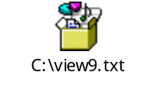

5.10. View with Check option:
The view below named as dept_budget has been created with Check option. The With Check option prevents the rows from being inserted or updated via the view, if the resulting rows fall outside the view. In the example below, the budget cannot be greater than 1000000.Hence in the Insert statement a value greater than 1000000 got violated and a failure occurred in the insert statement. Also a value cannot be updated through a view with check option if it violates any of the required constraints in the view.

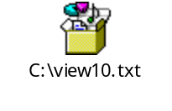

5.11. Failure of Creating a index on a View and Failure of using an Order By Clause in a View:
Here an attempt was made to create an index on the column in a view but a Failure message occurred as a index cannot be created on a view.
Here an Order by Clause was attempted to be inserted in the view but a failure 3706 occurred as seen above because the view named as Emp_view cannot contain an Order by clause.

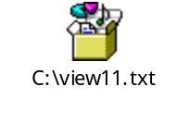

Key Points to Note:
- A View is a ‘Window’ into the data contained in relational tables. It may define a subset of rows and columns of a table. It may reference more than 1 table.
- Data can be accessed directly via the table or indirectly via a view based on the privileges held.
- View definitions are stored in the Data Dictionary, not in the user’s own space.
- A index cannot be created on a view. It cannot contain an Order by clause.
- View provides an additional level of security. Simplify end-user access to the data. Controls read and update privileges.
- Views are unaffected if a column is added to a table and if a column is dropped, unless the dropped column is referenced by the view.

6. Macro

6.1. Creation of Macro:
A Macro named as birthday_list has been created using the Create Macro statement. The macro below contains the columns last_name, first_name, birthdate of the table employee corresponding to department_number 201.

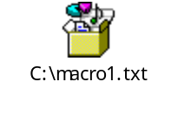

6.2. Replacing a Macro:
Here in the below statement, the macro birthday_list has been replaced with the macro birthday_list by just changing the sort sequence of the columns birthdate, last_name. The macro created with the Create macro is replaced with the Replace macro statement.

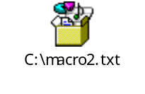

6.3. Creating a Parameterized Macro:
Here a parameterized macro named as dept_list is being created using the Create statement. The parameterized macro allows substitutable variables. Values for these variables are supplied at run time. In the macro dept_list below, the parameter: dept is a substitutable variable whose value is to be supplied at run time.

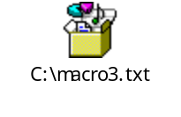

6.4. Parameterized Macro to insert data:

Here a parameterized macro named as new_dept is being created which inserts a new department row into the department table.

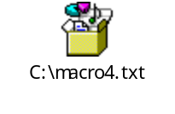

6.5. Executing the Insert Macro:
When executing the macro new_dept, the data is inserted into the macro as specified in the macro parameter list. The exact no of parameters are provided in the list. The
Positional commas or NULL are used for empty columns. Here as shown below 1st the inserts are made through the insert statements and then displayed through the Select statement. The data in the parameterized macro can be inserted in any order by including the parameter name with the value.

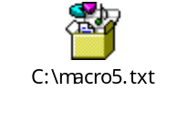

6.6. Upserts against UPI tables:
First the table account is created with a UPI on account_num and then a macro named as cred_lim is created which performs the Upsert operation. In the following example, if an account exists, add the transaction amount to the existing balance. If the account does not exists, insert the new account with the transaction amount as the opening balance.

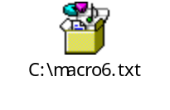

6.7. Upserts against NUPI tables:
Here first a Table customer_phone is created with a NUPI defined in it. The NUPI is created on customer_num. As shown below, a macro named as free_min is created which updates a customer account with a new amount of free monthly phone minutes. If the customer does’nt currently exist, insert the customer with the specified number of phone minutes. After creating the macro, it is executed and the values are updated /inserted based on the values entered.

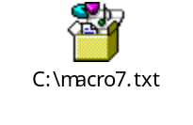

Key Points to Note:
- Macros contain one or more prewritten SQL statements. They are a Teradata extension to ANSI SQL. They are stored in the Teradata Data Dictionary.
- Executing a macro requires the user to have the EXEC privilege on the macro. They may contain only 1 DDL statement.
- The macro can be replaced by simply changing the Create Macro to Replace Macro. The Parameterized macro allows substitutable variables. Values for these variables are supplied at run time.
- While inserting the data in the table through the macro, the data to be inserted must be in the same order as specified in the macro parameter list.
The exact number of parameters must be specified.
- An Upsert is an operation which performs either a row update or a row insert depending on the pre-existence of the row. The Upserts can be performed against UPI tables and NUPI tables.

7. Creating, Modifying and Dropping users

7.1 Creating a user :
Create User statement enables you to add new users to the system. While creating a user permanent and password options must be specified .There is no Default.

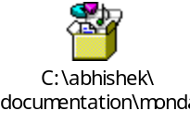

7.2 Modify User :
Allows to change the options that were specified when a user was created.
Using Modify User statement you can also assign /modify a profile to a user.

7.3 Drop User:
Drops the definition for an empty user from the data dictionary.
All objects associated with that user must have already been dropped.

7.4 Create Profile :
Creates a new profile that defines system parameters that a group of users can share. To use Create Profile, you must have the Create Profile privilege .New users do not implicitly have the Create Profile privilege. User DBC or a user who has the Create Profile privilege With Grant Option can grant this privilege to another user.

Key Points to Note:
CREATE USER is a Teradata extension to the ANSI SQL-99 standard.
CREATE USER is functionally equivalent to the ANSI SQL-99 CREATE SCHEMA statement.
MODIFY USER, Drop User is a Teradata extension to the ANSI SQL- 99 standard.
DROP USER is functionally similar to the ANSI SQL-99 statement DROP SCHEMA.
CREATE PROFILE is a Teradata extension to the ANSI SQL-99 standard.

8. Grant and Revoke

8.1 Grant Statement:
Grant statement is used to assign privileges or a role (set of privileges) to users. The privileges are the rights that can be given to users so that they can perform the activities permitted by those privileges. The list of access rights or privileges is as shown below:
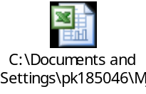
Few or all of these rights can be assigned to a user using grant statement .the grant statement takes the following form:
GRANT <set of privileges> ON <name of object like database, user, table, view, index, macro, trigger or stored procedure, function > TO <name of user>;
Read this as, the grantor (the user who is logged in) grants the specified set of privileges to the specified user (grantee) so that the user can perform the activities permitted by the privileges on the object like database, user, table, view, index, macro, trigger or stored procedure, function.
The following examples will give you an insight into how the statement works.
8.1.1) Grant create user clause will allocate the create privilege to user01 so that user01 will be able to create a user on the database customer_service.
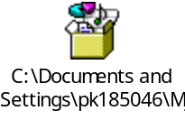

8.1.2)
In first statement, DBC will grant create user and drop user privileges on customer_service to user01 with grant option so that user01 gets an authority to grant the same privilege to some other user (in this case user02 from next statement).
In the second statement, user01 will create user02 for customer_service. That means, customer_service will be the owner of user02 and User01 (creator) will get all the creator’s rights (automatic rights) on user02 except privileges on procedures and functions (this can be checked with teradata administrator tool). But due to this statement, user02 will not get user privilege on customer_service, since user01 has not yet granted it explicitly to user02.
In third statement, user01 will grant this user privilege on customer_service to user02.

8.1.3) Grant to Public:
It means granting rights to all the children of DBC (super user). Keyword ‘PUBLIC’ is equivalent to ‘ALL DBC’.
Due to keyword ‘public’, only one row is added to dbc.accessrights table (dbc.allrights view) per right instead of one row per user per right. Hence, it reduces the overhead on dbc.accessrights table.

8.2 Revoke Statement:
The privileges which have been granted by using grant statement (explicit rights) or creator’s rights can be revoked using REVOKE statement. But ownership (implicit) rights can not be revoked using this statement but can only be taken away by transferring the ownership from one user to the other using GIVE statement.
8.2.1)
In 1st statement, only the grant authority of user01 over customer_service i.e. ability to grant create and drop user privilege is being revoked but its explicit rights remain intact (this can be seen with checkmarks against the privileges in teradata administrator tool).

In 2nd statement, those explicit rights are also being revoked (no checkmarks will be seen).

8.2.2) Revoke is passive, i.e. it does not add a row to the dbc.accessrights table but removes it.
Moreover, if the right which is granted on the database level is tried to be revoked at the object level, then that right does not get revoked in reality but it shows a message that revoke has been accepted.
This is why we say that revoke is passive. It doesn’t give you the actual picture of revoking rights. The following example makes it clear.

9. Create Roles

9.1 - Create Role:

Role is a set of access rights or privileges. A set of privileges can be assigned to a role and this role can be assigned to a user instead of granting the individual rights to him. This reduces the no. of rows in dbc.accessrights table, since a row is entered in the dbc.rolegrants table when a role is granted to a user.
A role may be granted to any other role as well as to other users.

9.1.1- create role, assign rights to it and grant role to a user
First a role is created and then list of privileges are assigned to a role and that role is granted to a user.
A tedious task of assigning many privileges to all the users can be reduced to assigning all the privileges to a role and then granting this role to all the users.

9.1.2- grant role with admin option
Granting a role to a user with admin option will give a role administration authority to a user so that a user will be able to grant or revoke that role to or from the other user and will also be able to drop the role.

10. Triggers
Triggers are of 2 types:
1) Row level triggers
2) Statement level triggers

10.1- Creating a Row level Trigger (before insert):

The row level trigger fires for each and every row in the DML statement (Insert, Update, delete) .

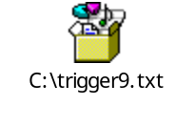

10.2- Creating a Row level Trigger (after insert)

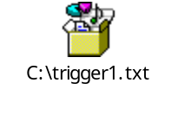

10.3- Creating a Row level Trigger (before update)
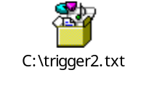

10.4- Creating a Row level Trigger (after update)

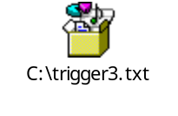

10.5- Creating a Statement level Trigger :

The Statement level triggers fires once for each DML statement.

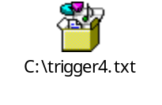

10.6- Cascading of triggers:
The trigger can cause another trigger to fire.
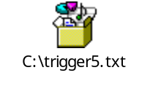

10.7- Ordering of triggers:
The triggers can be explicitly ordered in which they should fire.

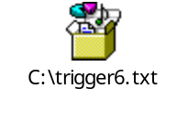

10.8- Backward References of triggers:

Triggers may have a backward reference that may cause recursion. The maximum level of recursion is 16.

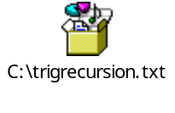

10.9- Changing the creation timestamp:

The triggers can be altered for example changing the creation timestamp, may be enabled or disabled, comments may be added, re-enabling a trigger.

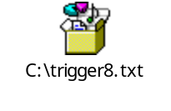

Key points to Note- :
- A trigger is an object in the database. Its a event driven procedure attached to a table.
- Triggering statement- 1) Fires the trigger2) May be insert, update, delete or insertselect.
- Triggered statement: 1)SQL executed as a result of triggering statement. 2)May be insert, update, delete, insertselect, abort/rollback.
- Cascading triggers are triggers that cause other triggers to fire.
- All statements associated with a trigger are treated as multi-statement request.
- Triggers may not be used with fastload, multiload or updateable cursors.

11. Stored Procedures

The Stored procedures are the compiled objects stored in the ‘stored procedure table’ which require perm space.
They are more secure in the sense that they require exec privilege to run as well as the privileges on the objects like tables they access.
It displays all the output parameters on its own as an output.

The stored procedure consists of two parts:
- SQL statements to access one or more rows from tables.
- Control statements to control the execution of the SQL statements.

11.1- Parameterized stored procedure :
The procedure which processes an IN parameter and outputs an OUT parameter.
Here, simple SET statements are being executed in the body of a procedure. The values which are displayed as a result are OUT parameters only and no any other values can be displayed.
Stored procedure script

To compile and run procedure

11.2- Parameterized procedure using IF-ELSEIF-ELSE statement:

Here, the IF statement is used to show the conditional operation of the procedure. This procedure shows zero or positive or negative No. as output depending on the input No. parameter.
Stored procedure script

To compile and run procedure

11.3- Looping procedure:
Create a looping procedure that gives output through the SET statement.
Stored procedure script

To compile and run procedure

11.4- WHILE-DO loop procedure:
The following procedure uses WHILE – DO looping structure.
Stored procedure script

To compile and run procedure

11.5- Retrieving a row from a table:
The following procedure retrieves a row from the table employee and displays it in the form of OUT parameters.
Create table

Stored procedure script

To compile and run procedure

11.6- Retrieving more than one row from a table (erroneous procedure):
The following procedure tries to select more than one row from a table which is not allowed by the procedure as its limitation.
Stored procedure script

To compile and run procedure

11.7- To drop constraints
The following procedure drops all the table level as well as column level named constraints. The cursor is used to retrieve one row at a time from all the retrieved rows and process on it. Here, two cursors are used to select rows one for table level constraints and other for column level constraints.
Create table with constraints

Stored procedure ‘sysexecsql’

Main stored procedure

To compile and run procedure

Key Points to note:
- Stored procedures are the objects which occupy perm space in the database.
- They have to be explicitly called for execution unlike triggers which are event driven.
- It can process only one row in its body (begin…..end) hence, to process multiple rows (one at a time), it uses cursor.
- If parameters are used as arguments, then IN parameters have to be provided with input values and OUT parameters are displayed as console output.

